Project Report Template



**1 INTRODUCTION**

**1.1 Overview**

                                                           Global warming is one of the biggest challenges currently being faced by the human race, although correlation is not causation, a likely cause of global warming is due to increased atmospheric carbon dioxide from human activities. CO2 Emission refers to the Carbon dioxide emitted throughout the world. For this analysis we will be focusing on CO2 Emissions and its Effects on the world we live in as  well as some key factors and stats that may play a role in the emissions of CO2 globally. Fossil Fuel use is the primary source of CO2. The data throws light onto how much fossil fuels are burnt, per year per nation, which amounts to an increase in CO2 every year. This will help researchers and environment experts to predict global warming. So countries should set a goal to decrease this amount yearly.

                     Analyzing Global CO2 Emission across countries from 1975 to 2020. This dataset contains a record of CO2 Emission by each Country and Region of Earth, here we are going to analyze and visualize Country wise, Region wise and Overall Co2 Emission on Earth.

**1.2 Purpose**

Through this project we can find the regions where electricity consumption is maximum in our country. We need to find out the reasons behind that and try to shortout the problem. So that the electricity consumption will reduce and we can save the electricity for our future generation.

**2 Problem Definition & Design Thinking**

2.1 Empathy Map

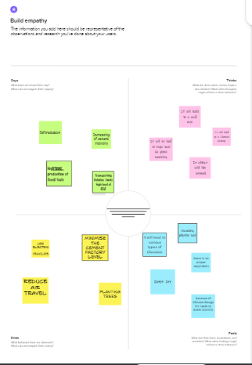

2.2 Ideation & Brainstorming Map

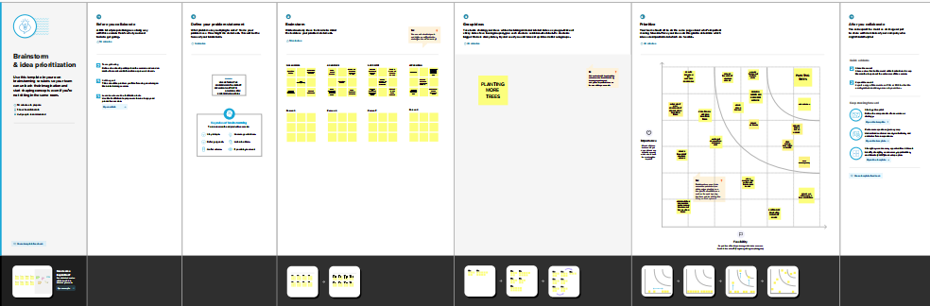

**3 RESULT**

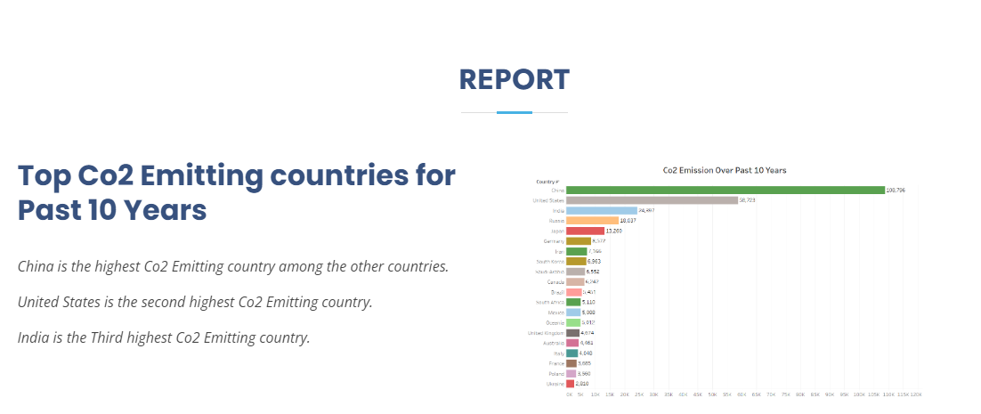

**4 ADVANTAGES & DISADVANTAGES**

**4.1 ADVANTAGES:**

**\***Green plants grow faster with more CO2.

**\***CO2 is used as in fire extinguishers, refrigerant, life jackets, blasting coal, foaming rubber and plastics and in carbonated.

**\***CO2 helps to trap heat in our atmosphere.

**\***It is essential for the survival of most living organisms and cycles in the ecosystem, through respiration, photosynthesis and combustion.

**\***It helps Earth hold some of the heat it receives from the Sun so it doesn’t all escape back into space

**\***It is used in a promoting the growth of plants in greenhouse.

**\***It is slightly toxic.

**\***It is one of the parts of medical gases because it promotes exhalation.

**4.2 DISADVANTAGES:**

**\***Cutting of trees leads to Global Warming.

**\***Humans have been increasing the amount of CO2 in the air by burning fossil fuels, producing cement, deforestation and by carrying out land clearing and forest combustion.

**\***Increase in CO2 is harmful to humans, aquatic animals, and plants.

**\***Combustion of carbon-containing fuels such as coal, oil, charcoal, wood, kerosene, leads to the formation of Carbon Monoxide.

**\***Avoid Plastics.

**\***It leads to Global warming.

**5 APPLICATIONS**

                 1.  CO2 is also widely used in food and beverage production, the fabrication of metal, cooling, fire suppression and in greenhouses to stimulate plant growth.

                 2.  CO2 in solid and in liquid form is used for refrigeration and cooling.

                  3. Major applications of liquid CO2 include food and beverages, desalination, cooling, cryogenic cleaning, welding and cutting and healthcare.

                    4.Much of the world’s electricity comes from burning fossil fuels like coal, natural gas, and oil. 63.3% of global relies on sources that emit CO2 and other greenhouse gases.

**6 CONCLUSION**

1. China has the highest CO2 Emissions with 9.9 billion tonnes of CO2 Emissions .
2. The United States with 4.4 billion tonnes of CO2 emitted.
3. The India with 2.3 billion tonnes of CO2 emitted.

**7 FUTURE SCOPE**

              1. The largest percentage of CO2 Emissions is from manufacture of cements. So use altenate product for cements.

              2.  Plant more trees for our future generation.

              3.  Reduce the usage of fossil fuels.

              4. Reduce the combustion of coals, charcoals, kerosene, and oil.

              5. It is necessary to keep solar panels in every house.

**8 APPENDIX**

A. Source Code

